|  |  |  |
| --- | --- | --- |
| File no: IRF19/7436  **Report to the Hunter and Central Coast Regional Planning Panel on an application for a site compatibility certificate under *State Environmental Planning Policy (Housing for Seniors or People with a Disability) 2004***  **Addendum Report – August 2020** | |  |
|  | |  |
|  |  |

**Report Purpose**

An application for a Site Compatibility Certificate has been made for self-contained dwellings on a site that is part of the Muree Golf Club at 7 Walker Crescent, Raymond Terrace.

The purpose of this report is to update the Department’s 2019 assessment report based on new information submitted by the applicant (Stimson Urban and Regional Planning) on 22 July 2020.

On 15 April 2020, the Central Coast and Hunter Regional Planning Panel determined to defer a decision on the application. The Panel identified the following matters that needed to be addressed so that the proposal could be considered compatible with surrounding land uses:

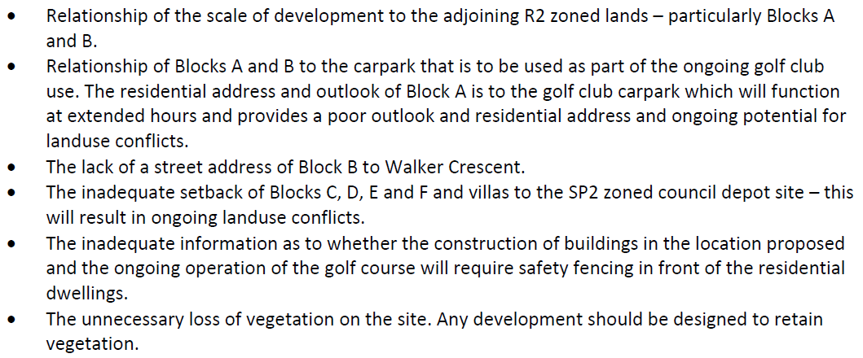

Figure 1: Panel list of issues

The Panel requested an amended scheme from the applicant within 40 days of receipt of the Panel’s decision. The applicant then requested a further 60 day extension to allow for commercial negotiations with Muree Golf Club on the amended scheme requested by the Panel.

The Department agreed to the extension (100 days in total), with the amended scheme to be submitted by 24 July 2020. The Department strongly encouraged the updated designs to be submitted well before this deadline. However, the revised application was received on 22 July 2020.

**SITE:** The is part of the Muree Golf Club at 7 Walker Crescent, Raymond Terrace. It is comprised of five lots – Lot 202 DP 610043, Lot 33 DP 40136, Lot 1 Sec 22 DP 758871, Lot 31 DP 753161 and Lot 8 Sec 24 DP 758871.

**APPLICANT:** The applicant is Stimson Urban and Regional Planning on behalf of Muree Golf Club.

**PROPOSAL:** The proposal has been reduced to 100 self-contained dwellings comprising:

* six three-storey buildings over semi-basement levels;
* four attached two-storey townhouses;
* community facilities, including a village green, playground, community room; and
* associated parking.

The applicant has provided further information to address the issues in Figure 1 and the Panel’s eight specific recommendations in Figure 3. **Attachment A2** provides the updated plans and **Attachment A4** provides the applicant specific response to the issues raised by the Panel.

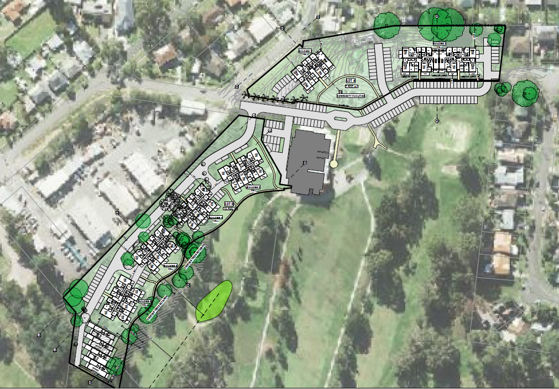

Figure 2: Proposed concept plan

**LGA:** Port Stephens

**PERMISSIBILITY STATEMENT**

The site is zoned RE2 Private Recreation under the *Port Stephens Local Environmental Plan 2013*. The proposed development is not permissible with consent under the Local Environmental Plan.

The proposed seniors living development relies on a site compatibility certificate (SCC) to allow the development application.

**PREVIOUSLY ISSUED SITE COMPATIBILITY CERTIFICATE ON THE LAND**

On 9 August 2016, an SCC was issued over the site for 61 self-contained seniors housing dwellings over a similar development footprint. This approval has since lapsed (**Attachment E**).

**PROXMITY OF SITE TO WHICH THERE IS A CURRENT SITE COMPATIBILITY CERTIFICATE, OR AN APPLICATION HAS BEEN MADE BUT NOT YET DETERMINED**

There are no current or lodged SCCs within a 1km radius of the site.

**CLAUSES 24(2) AND 25(5)**

The panel must not issue a certificate unless the panel:

* 1. has taken into account any written comments concerning the consistency of the proposed development with the criteria referred to in clause 25(5)(b) received from the general manager of the council within 21 days after the application for the certificate was made;
  2. is of the opinion that:
     1. the site of the proposed development is suitable for more intensive development; and
     2. the proposed development for the purposes of seniors housing is compatible with the surrounding environment and surrounding land uses having regard to the criteria specified in clause 25(5)(b).

**CLAUSE 25(2)(C)**

A cumulative impact study has not been prepared as there is no current SCC or an application for an SCC made but not yet determined for a seniors housing development within a 1km radius of the site.

**COUNCIL COMMENTS**

On 31 July 2019, Port Stephens Council provided comments on the original SCC application to the Department and indicated it supports the additional seniors living housing in the local government area (**Attachment C**).

In 2019, Council concluded the site is suitable for seniors housing, with the identified issues able to be addressed at the development application stage. It is not considered necessary to re-engage with Council on the revised scheme as the updated design is considered to reduce the impacts of the proposed development.

The key issues raised by Council in relation to the original application include the following:

Built form

The RE2 Private Recreation zone site has no height restriction. Council compared the planning controls over the site with the adjoining R2 Low Density Residential zoned land to the north and the R3 Medium Density zone beyond the Council depot. Both zones have a maximum building height limit of 9 metres.

Council acknowledged the *Raymond Terrace and Heatherbrae Strategy 2015-2031* proposes to increase the maximum building height of the R3 Medium Density Residential zone to 15 metres, and the proposal is consistent with this approach. Despite this, Council recognised the impact of the proposed development on the surrounding low density built form were important considerations in granting approval.

Buildings 1 and 2 (formerly Block A and B), which directly adjoin the R2 Low Density development to the north, are proposed to be four storeys in height. In Council’s view, the bulk and scale are not sympathetic to the surrounding R2 zoned land. Buildings 2 and 2 are proposed to be 12.4 metres, which will present privacy and overlooking issues to the private open space of the dwellings on Muree Street.

While Buildings 2 and 3 achieve a 1:1 height to setback ratio, the site is relatively open and slopes down towards the adjoining land, which exacerbates the impact on the privacy of these 8–9 dwellings.

Council identifies that Buildings 3 to 6 (formerly Blocks C to F) along the south-west boundary will be near noise and dust impacts from the Council depot. Council suggested increasing the setback from the south-west boundary may mitigate these impacts and an acoustic assessment report may be required to determine the required mitigation measures.

Council noted impacts relating to the bulk, scale, built form and character of the development will be considered as part of any future development application.

*Raymond Terrace and Heatherbrae Strategy 2015-2031*

The strategy indicates the suitability of seniors living and medium density development in the location as Raymond Terrace is a major regional centre that forms part of a primary growth corridor.

Council is satisfied that the proximity to Raymond Terrace Town Centre (1km) is an adequate distance to provide seniors with the necessary services and facilities required.

Other issues

Council raised several matters that will require consideration through the development assessment process including:

* the site is identified on the biodiversity values map and will require a biodiversity development assessment report for assessment of the Biodiversity Offsets Scheme;
* assessment will be required under the Comprehensive Koala Plan of Management; and
* the site is 400 metres to the nearest bus stop, which provides a public transport link to the town centre. Further assessment and subsequent upgrade of the connecting footpath and bus stop on Mount Hall Road to comply with the disability standards for accessible public transport will be necessary.

**PANEL DETERMINATION**

The Panel in its determination (**Attachment Panel**) on 15 April 2020 advised that the site could be considered suitable for more intensive development.

For the Panel to be satisfied that the use could be considered compatible with the surrounding land uses, the following amendments are required:

* + 1. *Block A to be reduced in scale by 1 storey;*
    2. *Greater separation is to be provided between golf course car park and Block A to mitigate potential conflicts between the ongoing use of the golf club and its functions and the proposed residential uses;*
    3. *Block B is to provide an address to Walker Crescent. Block B is to be reduced by 1 storey;*
    4. *Blocks C, D, E and F are to be setback from adjoining SP2 zoned land the equivalent of a street width – 17-20m;*
    5. *This separation is to accommodate road access for vehicles, including emergency vehicles, and landscape treatment to provide amenity and outlook to the units and retention of existing trees. Existing trees between the depot site and proposed building areas need to be retained;*
    6. *Removal of existing trees with the SCC are is no be minimised. This will involve the reduction in depth and/or length of building blocks;*
    7. *Proposed villas are to be deleted; and*
    8. *The above ground carparking needs to be appropriately treated and not be converted to residential use.*

The applicant has responded to these issues (see **Attachment A4 – Applicant response to Panel**) and made the following changes to the proposal:

* 1. Building 1 (formerly Block A) retains the same height as previous. The applicant considered the combination of building setback, reconfiguration of internal areas so no ‘active’ rooms face the northern boundary and presence of existing vegetation would provide an appropriate amount of separation to adjoining properties. (see **Attachment A4)**
  2. The landscape buffer has been increased between the carpark and Building 1. The applicant notes there is a level change and retaining wall that separates the two uses.
  3. Building 2 (formerly Block B) has been redesigned to utilised the slope of the site to provide basement car parking to reduce the height of the building from a 4 storey (12.4 metres) to 3 storey (9 metres and 11 metres) building and improve interface with Walker Crescent. Building 2 also has increased setback of 11 metres to Walker Crescent to allow for landscaping.
  4. Buildings 3 and 6 (formerly Blocks C and F) have been relocated 20 metres from the western boundary. Buildings 4 and 5 (formerly Blocks D and E) have been relocated 15 metres from the western boundary.
  5. The application states the roadway width complies with access requirements and there is a dedicated landscape zone on both sides of the roadway providing a buffer to the depot and outlook of residents. **Attachment A2** shows the new location of the buildings near the Council depot, including the respective vegetation clearing and retention for Buildings 4, 5, 6 and 7.
  6. Buildings 4, 5 and 6 have been relocated and spaced to preserve existing trees. The application states that all trees along the fairway edge are preserved. The plans indicate that there will be some removal of trees for Building 4, which the application states will be replaced with additional planting.
  7. The proposed villas have been retained in the amended scheme.
  8. Building 2 has been lowered with a partially submerged carparking providing street access to Walker Crescent. Buildings 3, 4, 5 and 6 are all accessed from a joint driveway.

The amended scheme also includes changes to the ninth hole with the tee box being moved, new bunkers and the green relocated to a position on the eastern side of the existing fairway opposite Building 5 around 500 metres away. There will be vegetation clearing associated with the realignment of the fairway and new putting green. This is an existing function that the golf club can undertake regardless of this application.

The distances to buildings also provide an indication of the risks, the key component is the changing of the angle of the fairway away from the buildings to reduce this risk even further. Building 5 is 49 metres from the centre of the new putting green and 22m to edge of the fairway. Building 6 and the Villas are 20 metres to edge of the fairway. There is no provision of safety netting as this is considered unnecessary.

**SUITABILITY FOR MORE INTENSIVE DEVELOPMENT**

The Panel must not issue a certificate unless it is of the opinion that the site of the proposed development is suitable for more intensive development (clause 24(2)(a)).

1. **The site of the proposed development is suitable for more intensive development (clause 24(2)(a))**

The 2019 assessment report (**Attachment Report**) considered the existing use, surrounding context, adjacent land uses, access and public transport. The report concluded the site was suitable for more intensive development.

The amended scheme has provided further details and changes regarding how privacy of neighbouring residential areas, and amenity impacts from the existing depot will be managed through:

* increased setbacks;
* redesign of internal layouts of buildings; and
* more defined separation between the golf club and residents.

**COMPATIBILITY WITH THE SURROUNDING ENVIRONMENT AND LAND USES**

The Panel must not issue a certificate unless the panel is of the opinion that the proposed development for the purposes of seniors housing is compatible with the surrounding environment and surrounding land uses having regard to the following criteria (clause 25(5)(b)) and clause 24(2)(b)):

The 2019 assessment report (**Attachment Report**) provided an assessment of the proposal against the criteria under this clause.

The Panel report (**Attachment Panel**) identified multiple issues (see Figure 1) which align with headings:

* 1. (Natural environment); and
* 5. (Bulk, scale, built form and character).

Buildings 3, 4, 5 and 6 have a reduced building height by one storey, being a reduction of 4 metres, and a total unit reduction of 8.

The design uses the slope to provide car parking so that the building elevation facing the Council depot boundary are 3 storey at the northern end and 4 storey at the southern (down slope) end, being a reduction of 4 metres.

**1. The natural environment (including known significant environmental values, resources or hazards) and the existing and approved uses of land in the vicinity of the proposed development (clause 25(5)(b)(i))**

The Panel identified the loss of vegetation and impact on adjoining neighbours and the existing golf course operations as issues for compatibility which are assessed under.

Natural environment and clearing

The golf course is identified as preferred koala habitat in Council’s Comprehensive Koala Plan of Management. The previous site for the proposed south-western buildings contains two potential koala habitat trees and two preferred koala habitat trees which have been confirmed as being retained. It is also noted that there have been no koala sittings on the site since the Highway bypass was constructed.

The flora and fauna assessment report recognises other areas of the golf course as containing endangered ecological communities (EECs), but no part of the development footprint contains EEC’s.

There will be no clearing of native vegetation for the proposed northern building clusters. The southern portion of the site will include the clearing of some trees and vegetation as set out in **Attachment A2 and A4**. The relocation of buildings and access/parking has balanced the retention and clearing of vegetation appropriately to manage the character and amenity impacts.

The impact of clearing under the *Biodiversity Conservation Act* will be considered at the development application stage.

Other existing and approved uses in the vicinity

Surrounding residential areas are typically low density single dwellings. The building height controls on adjoining residential land permit development up to 9 metres. The revised design and internal layout has improved the privacy of neighbouring residential areas, and amenity impacts from the existing depot.

The relationship between the proposed development and the existing registered club has been clarified through design elements clearly separating the operations of the golf course, such as car parking areas, with those of the seniors housing areas (see figure 4) and realigning the golf course to improve safety of residents.

**5. Without limiting any other criteria, the impact that the bulk, scale, built form and character of the proposed development is likely to have on the existing uses, approved uses and future uses of land in the vicinity of the development (clause 25(5)(b)(v))**

The Panel identified the following issues to be addressed which fall into the assessment under this heading of the SEPP as issues of compatibility:

* scale of the proposal compared to the adjoining residential areas;
* Building 2 addressing Walker Crescent;
* setbacks; and
* character – Building 2 addressing Walker Crescent.

The applicant provided a SEPP 65 Report for the concept design (**Attachment A3**) that includes building heights, depth and separation, setbacks and visual privacy matters against the Apartment Design Guide to support the revised plans.

The separated building layout offers a visual break between each building and allows some views of the landscape behind. This separated format also allows for better internal solar access and ventilation for each unit. The amended scheme has addressed the issues raised by the Panel and provides an appropriate scale of development for the neighbouring area and the existing golf club facilities.

The redesign to manage tree retention and amenity impacts for Buildings 3, 4 ,5, 6 and the Villas is considered adequate and addresses the issues raised by the Panel.

|  |  |  |  |  |  |
| --- | --- | --- | --- | --- | --- |
| **Building No** | **Units** | **Height (m)** | **Width (m)** | **Depth (m)** | **Setback (m)** |
| A | 24 | 12.4 | 60 | 22 | 16 north  20 east |
| B | 14 | 12.4 | 25 | 22 | 7.9 Walker Cr 4.65 side |
| C | 17 | 16 | 25 | 22 | 8.75 |
| D | 17 | 16 | 25 | 22 | 8.75 |
| E | 17 | 16 | 25 | 22 | 8.75 |
| F | 17 | 16 | 25 | 22 | 8.75 |
| Villas | 3 | 6 | 9 (x3) | 16 | 22 |

Table 1: Previous design dimensions (scaled from plan)

|  |  |  |  |  |  |
| --- | --- | --- | --- | --- | --- |
| **Building** | **Units** | **Height (m)** | **Width (m)** | **Depth (m)** | **Setback (m)** |
| 1 | 24 | 12 | 60 | 22 | 16 north 20 east |
| 2 | 12 | 9 (or 11 excluding fill) | 25 | 22 | 11 Walker Cr  8 side |
| 3 | 15 | 12 | 25 | 22 | 15 |
| 4 | 15 | 12 | 25 | 22 | 15 |
| 5 | 15 | 12 | 25 | 22 | 15 |
| 6 | 15 | 12 | 25 | 22 | 15 |
| 7 (Villas) | 4 | 6 | 7.6 and 8 | 25 | 9 |

Table 2: Updated design - proposed dimensions

The modern design of Building 2 will be a contrast to the existing buildings in the area. Figure 5 provides an indication of the likely character and built form, acknowledging that the development application level of design detail is not included in this concept design.

It is considered that the built form, scale and design of the proposal is a positive attribute to the character of the neighbourhood and provides diversity in building design for this locality. This takes into account the existing standard of housing construction and street appeal and the future desired outcomes for medium density housing in Raymond Terrace.

Building 2 will be a signature entry statement for the club and the other seniors housing buildings within the site.

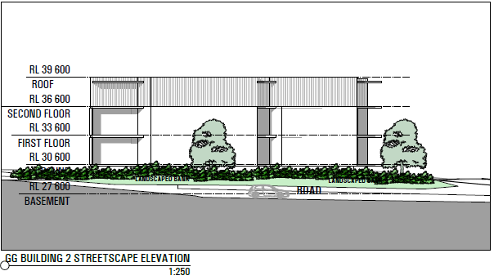Figure 5: built form of Building 2

**6. If the development may involve the clearing of native vegetation that is subject to the requirements of section 12 of the *Native Vegetation Act 2003*—the impact that the proposed development is likely to have on the conservation and management of native vegetation (clause 25(5)(b)(vi))**

The *Native Vegetation Act 2003* was repealed and replaced with the *Local Land Services Act 2013*. However, as this Act does not apply to land zoned RE2 (Private Recreation), the *Biodiversity Conservation Act 2016* applies.

While the flora and fauna assessment report recognises other areas of the golf course as containing EECs, and the golf course is identified as preferred koala habitat in Council’s Comprehensive Koala Plan of Management, no clearing of native vegetation is proposed, therefore this provision does not apply to the site.

**7. The impacts identified in any cumulative impact study provided in connection with the application for the certificate (clause 25(5)(b)(vii))**

As there are no issued SCCs or undetermined applications for an SCC within a 1km radius of the site, a cumulative impact study is not required.

**CONCLUSION**

The site is considered suitable for more intensive development to accommodate seniors housing, having regard to the criteria set out in clause 25(5)(b) of the Seniors Housing SEPP because:

* there are no major environmental constraints or hazards on the site;
* adequate and suitable services are available, including access to public transport and the provision of a community/shuttle bus;
* the redesign of the buildings has addressed potential privacy and amenity issues associated with adjoining lands;
* the relocation of buildings and access/parking has balanced the retention and clearing of vegetation appropriately to manage the character and amenity impacts; and
* the provision of suitable pathways that comply with the SEPP requirements can be required to be considered by Council in its assessment of the proposal;

Additional requirements proposed to be imposed on the SCC include:

* the location of living spaces, balconies and windows for Buildings 2 and 3 (formerly Block A and B) are aligned to address privacy of neighbours as set out in the plans as submitted to the Department on 27 July 2020;
* any proposal to open Sabre Avenue to Walker Crescent through the site is to be included in the development application and accompanied by a traffic impact assessment, including local traffic modelling; and
* a full assessment of the current car park usage (cars, trailers, buggies and service vehicles) and future demand associated with the golf club is to be included in the design of the proposal and submitted with the development application.

Contact officer: Dan Simpkins

Director, Central Coast and Hunter Region

Contact: 0466 358172

**ATTACHMENTS**

Attachment Panel

Attachment Report

Attachment A2 – revised plans

Attachment A3 – SEPP 65 report

Attachment A4 – Applicant response to Panel

Attachment C – Council comments

Attachment E – Previous SCC approval (2016)